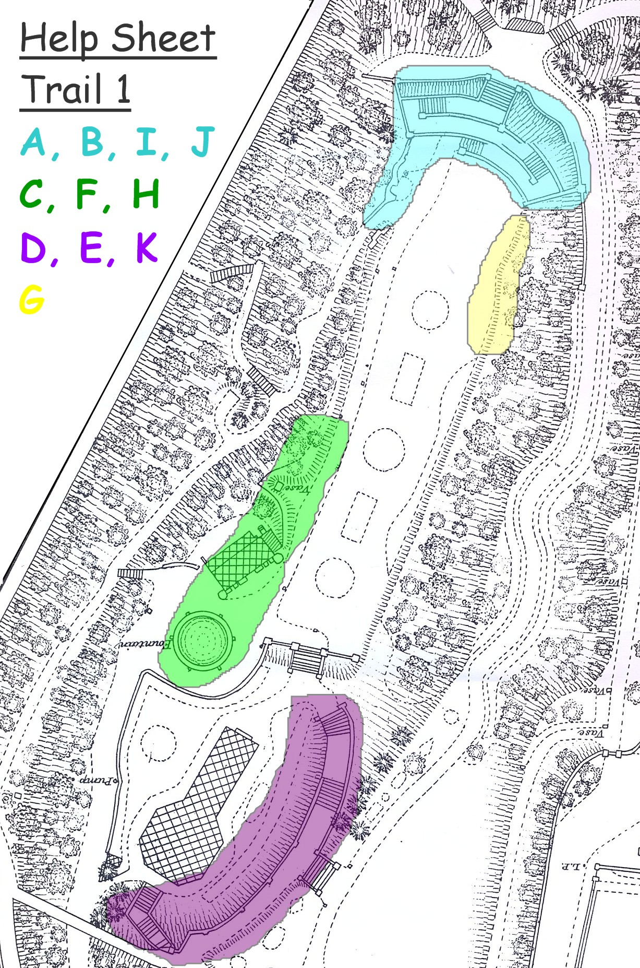

2
Help Sheet
Trail 2

