Plantation Garden Crossword
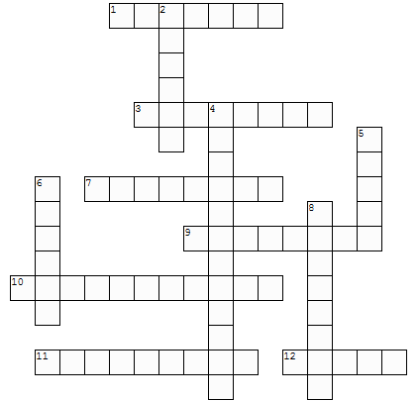
You might find the answers for the crossword in the guide books, on the website, on the information boards or in the garden itself!

(Created with the TeachersCorner.net Crossword Puzzle Generator)
Clues down:

2. What sort of service was held in the garden on Sunday August 1st 1886? (6) (Hint – there’s a sign somewhere in the garden that tells you!)

4. A scientist who studies insects.

5. First name of Mary Trevor’s Great-Grandson, written on one of the garden’s wooden benches. (8)

6. Surname of the man who created the Plantation Garden. (6)

8. First name of Henry Trevor’s Great-Granddaughter, written on one of the garden’s wooden benches. (8)

Clues across:

1. Word appearing in big letters in the wooden summer house at the top of the terrace. (7)

3. Word that appears on a white, stone bird-bath in the garden. (8)

7. First name scratched on a wall in tunnels under the Garden. (4,4) (You might find this in some of the stories on our website)

9. Appears on the Plantation Garden logo. (8)

10. Bees and butterflies are examples of these! (11)

11. Another word for rot (9)

12. First name of the man who created the Plantation Garden (5)

If you enjoyed the crossword, try creating your own and sending it in to us. We can put your crosswords on the website so other visitors can print them off and try completing them!

